**U11.1 – Data structures**

**LO1 - Define what the “memory heap” is and how C# interacts with it**

**LO2 - Explain the difference between a normal & multi-dimensional array and how they can be implemented**

**LO3 - Utilise 2D & 3D+ arrays to solve problems**

**Settler task**

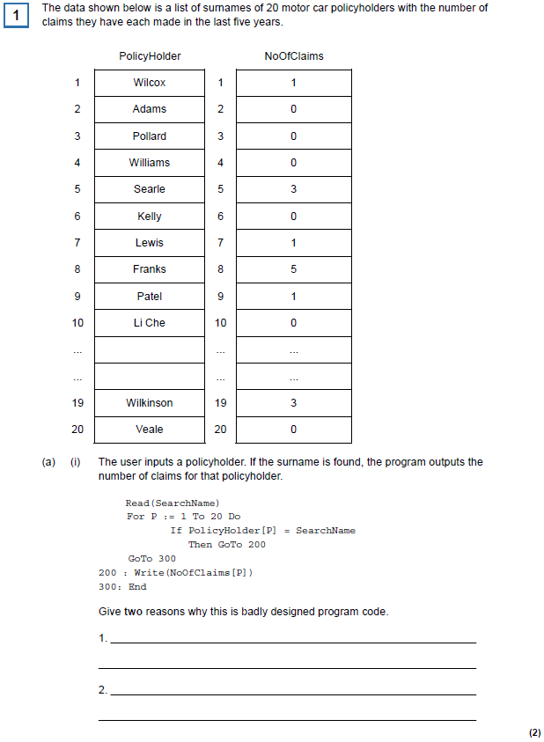

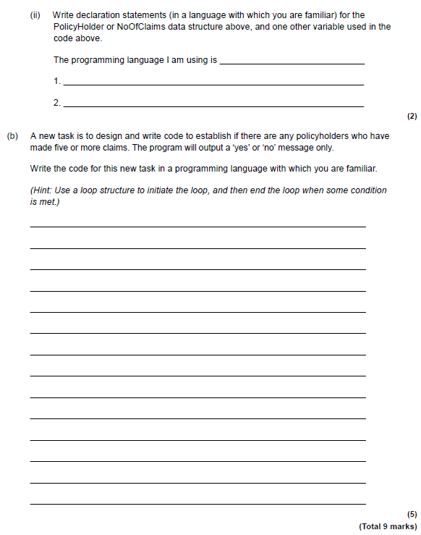

**S.1.a.i**

**S.1.a.ii**

**S.1.b**

**Task 1**

Study and run the following code.

using System;

public class multidimensional

{

public static void Main()

{

int i,j;

int[,] arr1 = new int[8,8];

Console.Write("\n\n Read a 2D array of size 3x3 and print the matrix :\n");

Console.Write("------------------------------------------------------\n");

/* Loop A - Stored values into the array */

Console.Write("Input elements in the matrix :\n");

for(i=1;i<8;i++)

{

for(j=1;j<8;j++)

{

Console.Write("element - [{0},{1}] : ",i,j);

arr1[i,j] = Convert.ToInt32(Console.ReadLine());

}

}

/* Loop B - Stored values into the array */

Console.Write("\n The matrix is : \n");

for(i=1;i<8;i++)

{

Console.Write("\n");

for(j=1;j<8;j++)

Console.Write(string.Format("{0,3} ", arr1[i, j]));

}

Console.Write("\n\n");

}

}

Below is a trace table. Complete the table with the values of each variable after each change in value.

|  |  |  |  |  |  |  |  |  |  |  |  |
| --- | --- | --- | --- | --- | --- | --- | --- | --- | --- | --- | --- |
|  |  | **arr** | | | | | | | | | |
| **i** | **j** | **[0,1]** | **[0,2]** | **[0,3]** | **[1,1]** | **[1,2]** | **[1,3]** | **[2,1]** | **[2,2]** | **[2,3]** |
|  |  |  |  |  |  |  |  |  |  |  |
|  |  |  |  |  |  |  |  |  |  |  |
|  |  |  |  |  |  |  |  |  |  |  |
|  |  |  |  |  |  |  |  |  |  |  |
|  |  |  |  |  |  |  |  |  |  |  |
|  |  |  |  |  |  |  |  |  |  |  |
|  |  |  |  |  |  |  |  |  |  |  |
|  |  |  |  |  |  |  |  |  |  |  |
|  |  |  |  |  |  |  |  |  |  |  |
|  |  |  |  |  |  |  |  |  |  |  |
|  |  |  |  |  |  |  |  |  |  |  |
|  |  |  |  |  |  |  |  |  |  |  |
|  |  |  |  |  |  |  |  |  |  |  |
|  |  |  |  |  |  |  |  |  |  |  |
|  |  |  |  |  |  |  |  |  |  |  |
|  |  |  |  |  |  |  |  |  |  |  |
|  |  |  |  |  |  |  |  |  |  |  |
|  |  |  |  |  |  |  |  |  |  |  |

**Extension:**

There is an inefficient use of the memory heap in this code. Explain where this is and how it could be improved.

**Task 2**

Create a booking system for a cinema in C#.

The cinema has 3 screens, 5 rows, and 5 columns of seats.

Users should be able to book a specific film and choose their seat in the corresponding screen room.

If the seat is already booked, the system should inform them of this and asked for another seat option.

Once an empty seat has been chosen, this change should be reflected in the system.

**Paste screenshots of your code here:**